Health Claims and Nutrition

Healthy almonds are a healthy addition to our daily diet:
• Rich source of healthy fats – almonds contain healthy unsaturated fats, predominantly monounsaturated fat (66% of total fat), plus have a low proportion of saturated fat (7% of total fat).6 Like all other plant foods, they are also cholesterol free.
• Excellent source of natural vitamin E – almonds are high in vitamin E with a 30g serve providing over 70% of the RDI.6, 7 Vitamin E is an important fat soluble vitamin and antioxidant which can help maintain a healthy heart.
• Contains natural plant sterols6 which can help to lower cholesterol levels by reducing cholesterol reabsorption in the intestine. Almonds contain 172mg of plant sterols per 100g.6
• Source of plant protein particularly amino acid arginine – almonds contain around 6g protein in every 30g handful.6 Arginine is converted to nitric oxide in the body. Nitric oxide causes blood vessels to relax and remain elastic, and helps prevent blood clotting. Hardening of the arteries and blood clotting can lead to heart disease.8

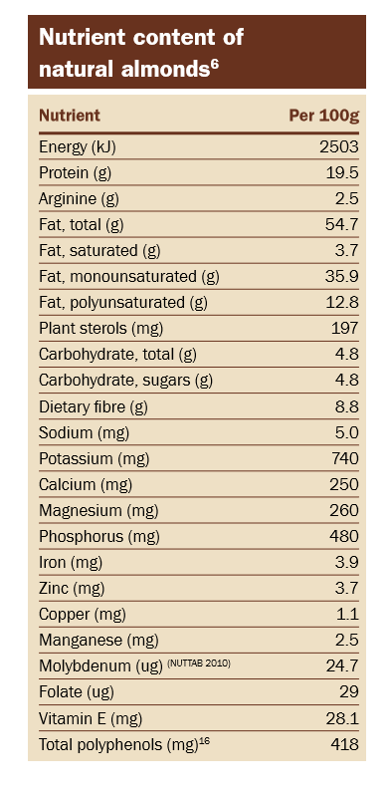

References
6. Nuts for Life. Nutrient Composition of Tree Nuts. Sydney: Nuts for Life; 2016
7. National Health & Medical Research Council. Nutrient Reference Values for Australia and New Zealand. Canberra, ACT: Australian Government Department of Health & Ageing 2006. www.nrv.gov.au
8. Ros E. Nuts and novel biomarkers of cardiovascular disease. Am J Clin Nutr. 2009;89(5):1649S-56S

